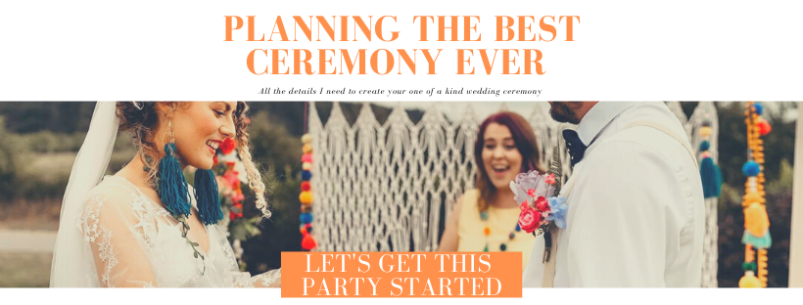

Date of ceremony
Venue and full address

Guest Arrival Time
Ceremony time ( can be approx.)
No of guests expected
Is there a specific vibe, style, colour palette or theme for the day?

Are you having a rehearsal? If so when?
Wedding Party (Please name each person, their role and their relationship to you)
Who is escorting you down the aisle? Please state their name and relationship to you
Partner 1
Partner 2

Please list suppliers involved in the wedding who may be there on the day… This can include but is not limited to Photographer, Videographer, Venue décor and styling, florist, DJ, wedding planner, etc…
What is the name and email of the venue coordinator?
What made you choose this venue? What do you love about it? Is there a specific area in the venue you want the ceremony in?
How have you found wedding planning? Have you contributed equal? Has someone said yes to everything the other wants?

Family Dynamics….
What are your parents name? Will they be attending? Are they still together? Do you have any new step parents? Who gets along and who can’t stand each other? Give me the gossip…..
What is your family heritage, culture, spiritual or religious background?
Are there any special customs or traditions you would like to include in the wedding?
Where are your guests travelling from? What cities? Anyone from abroad?
Would you like honour any one living or who has passed away and cannot attend the ceremony?

THE CEREMONY
What music have you decided on for during the ceremony??
Wedding party entrance before the couple ( optional )
Entrance of partner number 1
Optional partner two entrance
Exit of the newlyweds
Do you wish to include any readings or poems during the ceremony?
Who would you like to read them.. ( I can do this if no one feels confident )

What name would you like me to refer to you as during the ceremony? Ie first name, full name, nickname…
What pronouns would you me like to refer to you as during the ceremony?
Partner 1

Partner 2

Would you like to write some personal wedding vows to each other? ( don’t worry help is available )
Would you like to answer I do to some heartfelt vows? ( you can do these and personal vows )
Do you wish to exchange rings? If so do they have a significant meaning or history, such as passed down through the family, designed especially for the day, inscribed with a message etc..

ABOUT YOU
Where are you from, where did you grow up?
Where do you live now as a couple? What is your home like? House? Flat? Cottage in the countryside? Cosy city centre flat? Large mansion with a swimming pool?
Is this your first home together? If not, where else have you lived?
What do you do for a living, and do you enjoy it?
Do you have a philosophy you live by or anything you specific values and morals that are important for your marriage going forward?
What are your honeymoon plans?
Is there anything I need to keep secret from the guests?

What things about you both may I have fun with during the ceremony without embarassing you?
Do you want to surprise the guests in any way during the ceremony?
Would you to include any symbolic rituals during the ceremony? If so do you have any ideas, or would you like some ideas?
Would you like to include the guests in any symbolic rituals?
How do you want to be pronounced when exit the ceremony space?
