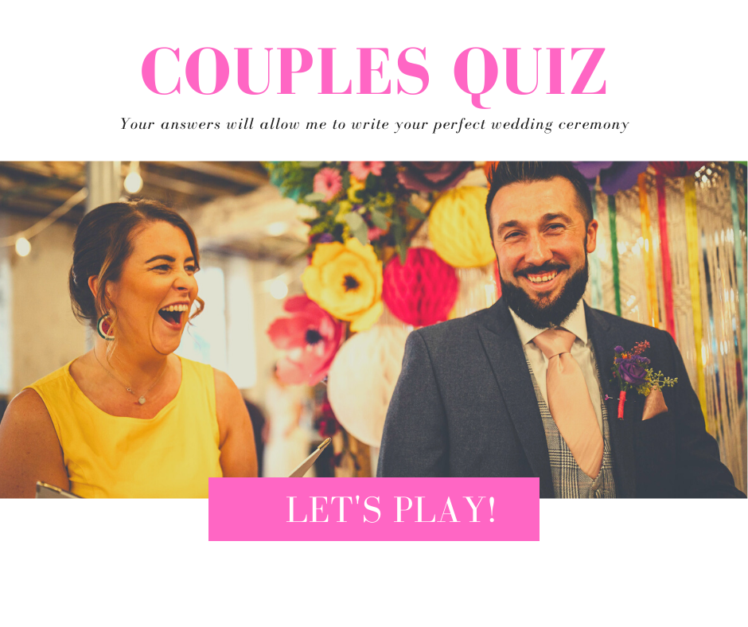

(Please complete one of these each and keep your answers a secret)
If I asked you to describe your other half and you couldn’t show me a picture what would you say?
How did you meet your partner?
What was your first impression of them?
Who asked who out? How did the other react?
What do you remember about your first date?
Did you hit it off right away or was it a slow burner?
How quicky did things get serious?
Were there any challenges? Crazy ex’s, disapproving parents etc…
When did you first realise you loved them?
Who said I love you first? Did the other say it back immediately?
How would describe your other half?
How would they describe you?
How have you changed as a couple during your time together?
What are your partners best qualities?
What about their worst?
What little things do you do in every day life to show your love and affection for each other?
Tell me the story of your proposal…
Why do you think you work so well as a couple?
Who else shares your home? Children, pets, parents, roommates?
What qualities do you bring out in each other?
What activities do you love to do as a couple in your spare time?
What do you love most about your partner? Give as much detail as you can.
Tell me about any significant moments in your relationship so far?
What does your partner do that always makes you smile?
Why do you want to marry them?
Do you think your relationship will change after you’re married? How?
What hopes and dreams do you have for your future as a married couple?
